

Lesken Assylnur, Kuzbaeva Yerkezhan, Madina Kairula, Malika Nurgalieva

Astana IT University

MT-2001 (Group 3)

WEB technologies

Aldiyar Salkenov

# **Overview**

Our web technologies teacher told us to split into groups of 4-5 people, and Asylnur, Madina, Malika and Symbat and Yerkezhan decided to create a group, but one participant - Symbat took the academic year and left the project regarding to her health issues. Asylnur was the head of the group, Malika was writing the codes , Madina was searching for the needed information, and Yerkezhan - I am writing a report , and also writing the needed text for the snacks.

# **Project goals and team interests**

This website is needed to the ones , who doesn’t like to stay in a queue , also it will be helpful for the employers and the students.

So, we started our work from scratch The theme of the project was the same for all - the canteen of the university; each group had to invest in this project all their knowledge, creative ideas and implement them in the form of a website. Initially, we needed a plan according to which we will make our website step by step. Actually the goal of this project is to collect all of the snacks and create the website from where you can book the place and choose the meal , so you don’t need to stay In a queue. And also in my point of view , our group will improve the teamwork skills and will higher the level of css and html knowledge.

**Phases and Deadlines**

We have divided this website project into 4 phases:

1) HTML and CSS code (creating the objects) - 2nd February 00:00

2) Bootstrap (grid), carousel - 3rd February 12:00

3) Design and colors - 5th February 16:00

4) Writing the report – 6th February 12:00

# **Content structure**

**Site map**

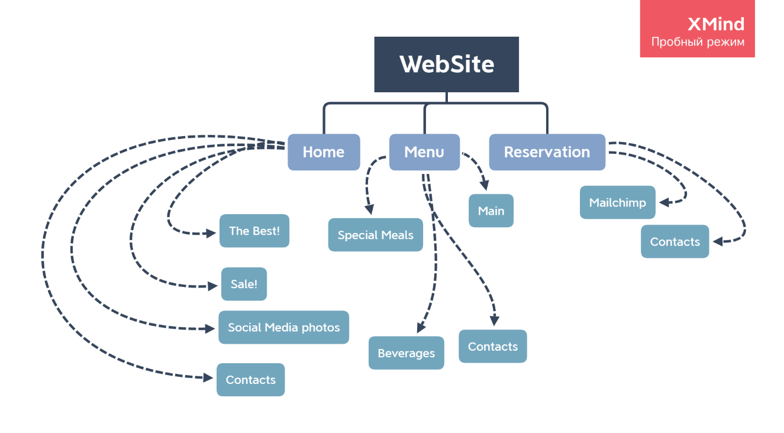

**Content types**

Home - news, events

Menu - list of dishes.

Booking - ordering

Contact- Comments.

**Design**

* Reference links <https://images.app.goo.gl/tjoueNybFdNTDis8A>
* Image files <https://github.com/Assylnur/AITU_MT2001_Group-3.git>
* Colours:

#5A5A54

#CC9090

#E79D9D

#F5D2BD

#fcfcfc

* typography rules:

<!-- google fonts -->

<link rel="preconnect" href="https://fonts.gstatic.com">

<link href="https://fonts.googleapis.com/css2?family=Bree+Serif&display=swap" rel="stylesheet">

<link rel="preconnect" href="https://fonts.gstatic.com">

<link href="https://fonts.googleapis.com/css2?family=Lobster&display=swap" rel="stylesheet">

* hover states

.projectImg:hover{

transform: scale(1.1);

}

* animations:

<script src="https://ajax.googleapis.com/ajax/libs/jquery/3.5.1/jquery.min.js"></script>

<script src="https://cdnjs.cloudflare.com/ajax/libs/popper.js/1.16.0/umd/popper.min.js"></script>

<script src="https://maxcdn.bootstrapcdn.com/bootstrap/4.5.2/js/bootstrap.min.js"></script>

* grid systems: https://getbootstrap.com/docs/5.0/utilities/spacing/
* spacing:

images: margin: 10px 20px 50px 10px;

html, body: margin: 0px; padding: 0px;

**Functionality**

According to the functionality of website , it is very simple . In the top of the website there is a menu , beverages, contacts, special meals .

In the Menu there are Beverages and Special meals – which include all the catalogue of the foods , snacks and drinks . And there is another page of reservation where you can book the place , so you can enter there your name , emails and individual information , so it will be send to us and we will receive your order. Also clicking to the contacts button , you can see the Instagram page of canteen

**Hosting and Accessibility**

Also , in order to this website be accessible , we have downloaded it on the github , watching the video on the moodle how to do it.( https://github.com/Assylnur/AITU_MT2001_Group-3.git) And we used the bootstrap grid to the website be accessible on wide range of devices.



# **Summary**

To conclude – it was an interesting experience – to do the website by ourselves without any help . We have learned how to work in team , and leveled up our knowledge regarding to the website creating .Of course, we had some problems , but all the problems gone out of mind when we have seen the final result of the website , hope that you will also like it !